**UNSW Student Network Platform Project**

**PROJECT MANAGEMENT PLAN**

**1. Project Charter ------------------------------------------------------------------------------------------------ 4**

1.1. Purpose Statement ------------------------------------------------------------------------------------------ 4

1.2. Requirements ------------------------------------------------------------------------------------------------- 4

1.3. Assumptions --------------------------------------------------------------------------------------------------- 4

1.4. Objectives ------------------------------------------------------------------------------------------------------ 5

1.5. Definition of Success ---------------------------------------------------------------------------------------- 6

1.6. Summary of Stakeholder ----------------------------------------------------------------------------------- 7

1.7. Summary of Schedule --------------------------------------------------------------------------------------- 7

1.8. Summary of Budget ------------------------------------------------------------------------------------------ 8

1.9. High Level Risks ---------------------------------------------------------------------------------------------- 8

1.10 Summary of communication ------------------------------------------------------------------------------ 8

1.11 Summary of Resources ------------------------------------------------------------------------------------ 8

**2. Scope Management ------------------------------------------------------------------------------------------ 8**

2.1. Overview of Scope Management (PMBOK Referenced Discussion) --------------------------- 8

2.2. Deliverables ---------------------------------------------------------------------------------------------------- 8

2.3. Scope Statement --------------------------------------------------------------------------------------------- 10

2.4. WBS ------------------------------------------------------------------------------------------------------------- 10

**3. Stakeholder Management** ----------------------------------------------------------------------------------- 11

3.1. Overview of Stakeholder Management (PMBOK Referenced Discussion) --------------------- 11

3.2. Stakeholder Identification ------------------------------------------------------------------------------------ 11

3.3. Stakeholder Assessment (Power&Interest, Power&Influence Grids) ----------------------------- 12

3.4. Stakeholder Engagement (Stakeholder Engagement Matrix) -------------------------------------- 13

**4. Schedule Management ---------------------------------------------------------------------------------------- 14**

4.1. Overview of Schedule Management (PMBOK Referenced Discussion) ------------------------- 14

4.2. Gantt Chart ------------------------------------------------------------------------------------------------------- 14

4.3. Network Diagram ----------------------------------------------------------------------------------------------- 15

**5. Budget Management** **------------------------------------------------------------------------------------------ 16**

5.1. Overview of Budget Management (PMBOK Referenced Discussion) --------------------------- 16

5.2. Budget Estimation Table ------------------------------------------------------------------------------------ 16

5.3. Integrated Project Budget (Time Phased Budget) ---------------------------------------------------- 16

**6. Risk Management --------------------------------------------------------------------------------------------- 17**

6.1. Overview of Risk Management (PMBOK Referenced Discussion) ------------------------------ 17

6.2. Risk Identification (Risk Breakdown Structure) ------------------------------------------------------- 17

6.3. Risk Assessment --------------------------------------------------------------------------------------------- 17

6.4. Risk Register (Response and Contingency Plan). --------------------------------------------------- 18

**7. Communication Management ------------------------------------------------------------------------------- 19**

7.1. Overview of Communication Management (PMBOK Referenced Discussion) ----------------- 19

7.2. Primary Communication Materials ------------------------------------------------------------------------- 19

7.3. Project Communication Plan -------------------------------------------------------------------------------- 20

**8. Human Resource Management ------------------------------------------------------------------------------ 21**

8.1. Overview of Human Resource Management (PMBOK Referenced Discussion) ---------------- 21

8.2. Project Organization Chart ------------------------------------------------------------------------------------ 21

8.3. Roles and Responsibilities ------------------------------------------------------------------------------------ 21

8.4. Training and Development ------------------------------------------------------------------------------------ 25

8.5. Change Management ------------------------------------------------------------------------------------------ 25

**Reference** **-------------------------------------------------------------------------------------------------------------- 26**

**Appendix** **--------------------------------------------------------------------------------------------------------------- 26**

# 1. Project Charter

## **1.1. Purpose Statement**

To connect students with peers and industry professionals to create study groups, perform language exchanges and further career development. This aligns with all three pillars of the UNSW “Strategy 2025” vision.

## **1.2. Requirements**

**Technique Requirements**

* Students must be able to create and join study groups.
* Students must be able to exchange languages with each other.
* Students must be able to connect with industry professionals.
* The platform must be secure and user-friendly.

**Project Requirements**

* The UNSW Student Network Platform must meet the following non-functional requirements:
* The platform must be accessible to all UNSW students, regardless of their location or circumstances.
* The platform must be scalable to accommodate a large number of users.
* The platform must be reliable and available 24/7.

**Bonus Requirements**

* The platform should be creative and innovative, with features that go beyond the basic functionalities.
* The project should include stakeholder engagement and feedback throughout the process.
* Any further work required to commission and operate the platform should be considered.
* Consideration should be given to the engagement efforts that will be required to make students and staff aware of the platform and to encourage them to start using it.
* The project team should consider what type(s) of information they will need to access from existing university systems.

## **1.3. Assumptions**

**Constraints**:

* Budget: The project budget is capped at $400,000, and this includes all personnel salaries, equipment, licensing fees, and other miscellaneous costs.
* Human Resources: The project will be executed by a dedicated 6-person team, and any need to expand the team will require stakeholder approval and might exceed budget constraints.
* Time: All project activities, from initiation to closure, must be completed within 6 months.
* Stakeholder Requirements: Any modifications to the project must align with stakeholder interests and the Vision 2025 objectives.
* Integration with myBcom_UNSW: The platform should not only serve postgraduate students but should also efficiently integrate undergraduates from the existing myBcom platform.
* Technical Specifications: Any software or hardware utilized should be compatible with UNSW's existing systems.
* Regulatory Compliance: Given that the platform deals with student data, it must comply with Australian data privacy regulations.

**Assumptions:**

* Stakeholder Collaboration: All primary stakeholders, such as UNSW School of Computer Science & Engineering, UNSW Engineering faculty, and the UNSW Student network management team, will actively collaborate and provide necessary resources and feedback.
* Hardware/Equipment Suppliers: Suppliers will provide necessary training and will ensure timely delivery of required equipment.
* Maintenance: The UNSW Student network management team will be responsible for the long-term maintenance and updates of the platform post-deployment.
* Secondary and Minor Stakeholders: The interests of secondary and minor stakeholders are aligned with the project's objectives, and their support will enhance the project's outreach and success.
* Change Management: Given the platform's innovative nature, there might be resistance from some user groups, but with proper training and the Change Management Specialist's initiatives, the platform will be widely accepted.
* External Support: External teams like the UNSW Employability team and the Business & Research Partners team will actively promote and integrate with the platform to ensure its success and widespread adoption.

## **1.4. Objectives**

The objective of the project is to create a virtual platform that connects UNSW students with each other and with industry professionals, providing a variety of features to support student learning and development.

The project is aligned with UNSW’s 2025 Strategy: “to improve lives globally through innovative research, transformative education, and commitment to a just society”. This project exemplifies the strategy in the following ways:

**Academic Excellence:**

* The platform will provide students with an opportunity to form study groups based on their interests and location, which will help them to learn more effectively.
* The language exchange feature will enable non-native English speakers to practise their English and presentation skills with native speakers, which will enhance their communication skills.
* The platform will connect students with industry professionals who can offer guest lectures, mentorship, and job opportunities, which will provide them with valuable insights into the industry.

**Innovation and Engagement:**

* The platform will be creative and innovative, with features that go beyond the basic functionalities.
* Stakeholder engagement and feedback will be incorporated throughout the process to ensure that the platform meets the needs of its users.
* The project team will consider what type(s) of information they will need to access from existing university systems, which will help them to create a more integrated platform.

**Social Impact:**

* The platform will provide a safe and supportive environment where students can connect with each other and with industry professionals, which will help them to develop their careers.
* The platform will be accessible to all UNSW students, regardless of their location or circumstances, which will promote inclusivity.
* The project team will consider what type(s) of information they will need to access from existing university systems, which will help them to create a more integrated platform.

## **1.5. Definition of Success**

To assess the success of the UNSW Student Network Platform project, the following success criteria have been established. A project will be considered successful if it achieves an overall score of 195 or above based on the outlined criteria. Evaluation will be conducted from the perspective of the project management team, keeping in mind the project objectives and scope established in the project charter.

|  |  |  |
| --- | --- | --- |
| **Category** | **Criteria** | **Success Rubric** |
| Time | Project is completed within the 6-month timeline | On time: 20 Up to two weeks of delay: 15 Up to four weeks of delay: 10 Over four weeks of delay: 5 |
| Budget | Project is completed without exceeding the $400,000 budget | On or below budget: 20 Over budget by 5%: 15 Over budget by 10%: 10 Over budget by 20%: 5 |
| Scope | All items detailed in Sections 2.2 and 2.3 are delivered | Yes: 20 No: 5 |
| Functionality | Deliverables are in alignment with project objectives | Yes: 20 No: 5 |
| Platform meets both functional and non-functional requirements | Yes: 20 |
| Policy Considerations | Platform aligns with UNSW's policy restrictions | Yes: 20 No: 5 |
| Project meets all regulatory guidelines | Yes: 20 No: 5 |
| Certification | Achievement of Centre of Excellence Certification | Yes: 20 No: 5 |
| Liability | No personal or data injuries incurred over the project duration | Yes: 20 No: 5 |

## **1.6. Summary of STAKEHOLDERS**

Key stakeholders include current, future, and alumni students, industry professionals, UNSW Employability team, UNSW business & partners team, UNSW mybcom, the project team spanning various UNSW departments, and hardware suppliers. Secondary stakeholders encompass other schools and research alliances, with the Australian government & policy makers being minor stakeholders. Stakeholder identification aligns with the 2025 UNSW Strategy Update, emphasising knowledge exchange.

According to Interest/Power Grid and Influence/Power Grid, it's vital to strategize considering all interests, with emphasis on the powerful stakeholders who are most of key stakeholders in this project.

In terms of stakeholder engagement, according to Stakeholder Engagement Assessment Matrix, most stakeholders, including students, professionals, and industry partners, are currently 'Neutral', aiming to shift to 'Supportive'. The chart aids in strategizing stakeholder involvement effectively.

## **1.7. Summary of Schedule**

The estimated duration for the UNSW Student Network (IT Project) is projected to span 6 months, commencing on September 11, 2023, and concluding by March 9, 2024. This timeframe is predicated on the assumption that the necessary personnel will be onboarded prior to the initiation of the project, as elaborated in Section 8.3, "Onboarding Human Resources". It should be noted that the duration does not incorporate the period dedicated to post-implementation user support. Our projections set the post-implementation user support at a duration of 6 months or a cumulative 650 hours, with a cap of 14 support days, commencing post-project completion.

For a comprehensive view of the project's timeline, please refer to the Gantt Chart and Network Diagram outlined in Sections 4.2 and 4.3, respectively.

An initial breakdown of the activities tied to each work package is available in Section 5.1, "Appendix – Detailed Budget and Schedule". A condensed schedule is delineated in Table 5 below.

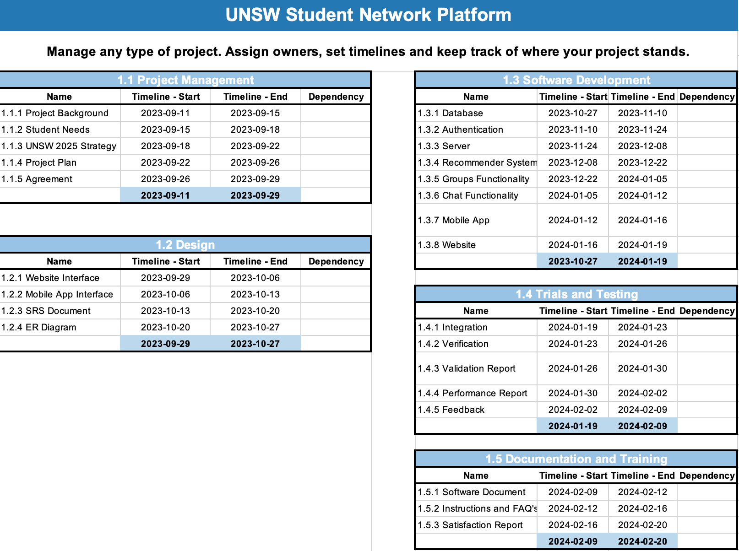

## **1.8. Summary of Budget**

The allocated budget for the project is $400,000. A detailed structure of the budget and the time phased budget are available later in the PMP.

## **1.9. High Level Risks**

Risk management for the UNSW Student Network Platform project involves identifying and addressing a range of potential risks, including four factors. Each risk is assessed for their likelihood and impact. Mitigation strategies and contingency plans are established to minimize these risks and ensure project success by proactively managing uncertainties and challenges.

## **1.10 Summary of Communication**

Communication management will focus on how to maintain a channel for communication between different stakeholders and project teams. It can ensure the project works well under the current schedule, budget, and scope. The necessary communication documents and details of the communication plan are included in the communication part.

## **1.11 Summary of Resources**

The UNSW Student Network Platform's success hinges on a six-member team, comprising external professionals and internal experts, aligned with the project's schedule and Work Breakdown Structure. The Project Manager oversees project coordination, stakeholder engagement, and risk management. The Technical Lead manages technical aspects, working closely with the development team. Two Development Engineers design technical components. The HR Manager handles recruitment and team dynamics. Internal experts include the Communication Coordinator, Change Management Specialist, and Training and Development Specialist. Training is tailored for non-technical team members. Effective change management is a priority, with collaboration between the Change Management Specialist and HR Manager. In essence, the project's triumph rests on a diverse, well-structured team, customised training, and adept change management for a seamless platform implementation.

# 2. Scope management

## **2.1 OVERVIEW OF SCOPE MANAGEMENT**

This project aims to deliver an online platform that meets its goals of fostering student connections, enabling language exchanges, and promoting career development. The scope encompasses the development of essential features like user profiles, a central control system, and educational resource pools. Regular reviews will validate adherence to the scope, and any changes will undergo a rigorous approval process. This approach ensures the project remains on track, meets its objectives, and satisfies stakeholder expectations.

## **2.2 DELIVERABLES**

The primary deliverable for this project will be an online platform which includes software and hardware with support and maintenance resources.

**2.2.1. Project documentation**

The project documentation will describe all the information necessary to properly create, operate, maintain, and extend the system’s hardware or software components.

**2.2.2. User profile**

The user profile will offer a user-friendly interface for sign-up and personalization. The user profile information can help build networking between students and professionals. An advanced matching algorithm will connect users based on interests and needs. Integration with existing university systems will provide accurate academic data representation. User activity analytics, feedback mechanisms, and dedicated support will enhance the user experience. All the data will be protected by robust security features.

**2.2.3. Central Control system**

The Central Control System (Hardware) serves as the underlying infrastructure that supports the UNSW Student Network Platform. This component is essential for ensuring the platform's smooth operation and scalability. The key deliverables for this section encompass the hardware aspects:

The Hardware Architecture Design document will provide an overview of the central control system's architecture. It will detail the specifications of servers, network infrastructure, and data storage solutions, emphasising scalability and redundancy considerations.

The section on Server Procurement and Configuration will outline the process of acquiring servers, their specific configurations, and the setup process. It should address load balancing and failover mechanisms to ensure uninterrupted service. Security measures will be documented, including the hardware components like firewalls, intrusion detection systems, and encryption methods, aimed at safeguarding user data and the platform's integrity.

**2.2.4. UNSW career high system**

The UNSW Career High System is a pivotal component of the platform, designed to manage language exchange, tutoring programs, and academic collaborations. Key deliverables for this software system include:

A Feedback System will be detailed, explaining how users can provide feedback for quality control, how it is processed, and the improvements it may trigger.

User manuals and support resources, such as tutorial videos and FAQs, will be provided to assist users in navigating and using the UNSW Career High System effectively.

The Testing and Quality Assurance process will be described, encompassing unit testing, integration testing, and user acceptance testing to ensure the software's quality. Compliance and security measures will be integrated to ensure that the software complies with data security and privacy regulations. This will include details on encryption, access controls, and compliance documentation.

**2.2.5. Study resource pool**

The Study Resource Pool will offer students and professionals an interface to easily share and access educational materials. Features will include a robust search system, secure storage with backup, quality control measures for uploaded content, and tools to facilitate collaboration and feedback. Additionally, it will be accessible across various devices and will adhere to copyright and licensing regulations. Comprehensive user support and maintenance will be provided.

**2.2.6. Deployment trial**

The deployment trial phase is essential for testing the online platform before its full launch. Its deliverables include a Deployment Plan outlining the trial's strategy, tools for collecting user feedback, set Key Performance Indicators (KPIs) to assess platform functionality, a report summarising trial outcomes, and recommendations for improvements before the full-scale launch. This trial ensures that the platform is user-friendly, functional, and aligned with the project's objectives. Any issues identified will be documented, with resolutions proposed. This feedback-driven approach aims for a seamless launch for the UNSW community.

**2.2.7. Advertisement plan**

The advertisement plan will outline the strategies and tactics for promoting the platform to UNSW students and industry professionals. The promotion will be conducted through email, video on social media and referral programs. The above promotion can ensure maximum reach and user engagement.

**2.2.8 Training resources**

Essential training resources for both engineers and users, such as maintenance manuals, user manuals, tutorial videos and FAQ Section, will be provided for easy user adoption.

## **2.3. SCOPE STATEMENT**

The project is set to deliver a comprehensive virtual platform exclusively for UNSW students and verified industry professionals, enabling them to form study groups, engage in language exchange, and foster career development through their phones or computers. Set to commence in the third term of 2023, the initiative has a stringent 6-month timeline with a budget capped at $400,000. The platform will operate 24/7, accommodate numerous simultaneous users, and must be in line with the UNSW 2025 Strategy Update. Our deliverables encompass holistic project management such as stakeholder strategy, communication, and analysis; meticulous software design, development, and integration with an appropriate database; a deployment trial followed by thorough evaluation; pertinent advertisement campaigns; standard engineering documentation; as well as a system for feedback collection and maintenance support. On the other hand, Deployment of the cloud platform will be limited to pilot colleges and any further system updates post-project completion are not covered within this scope.

## **2.4 WBS**

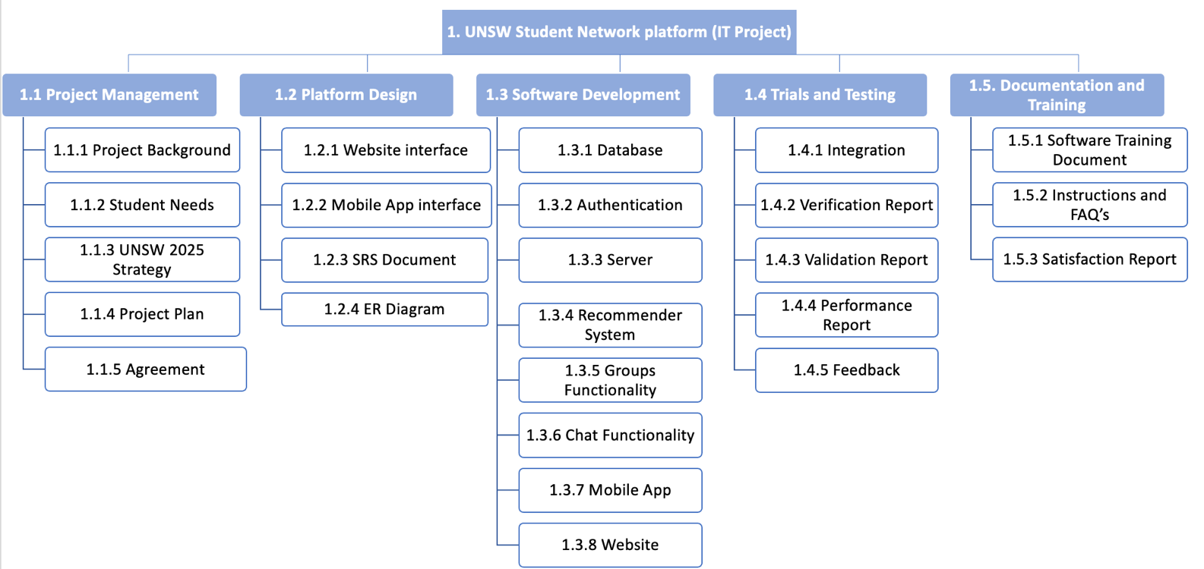

# 3. Stakeholder management

## **3.1 OVERVIEW OF STAKEHOLDER MANAGEMENT (PMBOK REFERENCED DISCUSSION)**

Stakeholder consideration is a key component when completing the UNSW Student Network Platform. The project accomplishes this by identifying the stakeholders and making appropriate assessment, engagement plans to drive the entire project and build the UNSW Student Network Platform.

## **3.2 stakeholder identification**

**3.2.1 How you identify your stakeholders?**

This project shows excellent alignment with 2025 Strategy Update in UNSW, particularly in terms of Knowledge Exchange. Based on the project charter, Brainstorming, data gathering helps me to do identifying the stakeholder of this project.

**3.2.2 Who are your stakeholders?**

Completing a project on time, within budget, and meeting performance standards is crucial. Early identification of stakeholders is vital, ensuring the project aligns with the primary expectations of the project owner.

3.2.2.1 Primary stakeholders:

* Student who directly get benefit from this Network platform:

Current: This project will offer to current students with a student learning experience as well as the chances to develop their careers. In addition, it also provides belonging to students by connecting with other students or industry professionals.

Future: Future students in UNSW could consider choosing the Student Network platform when they need a supportive environment.

Alumni: UNSW's alumni numbers have risen due to consistent graduations. Many have used the Student Network platform during their studies. As these alumni transition to industry professionals, they can become mentors, leveraging their platform experience and professional knowledge. Reconnecting with UNSW through the alumni community, they contribute by giving talks, offering specialized training, and sharing insights, enhancing the learning environment for current students.

* Industry professionals: This project can support equipment and technology to do mentorships, guest lectures such as matching right mentor and mentee.
* UNSW Employability team: This existing team could be corporate with UNSW student Network platform to support the student in terms of providing career development and promote the platform by sending emails, making short video to advertise it.
* Business & Research Partners team in UNSW: This team could recommend mentor/lecturer and manage them to access to academic and physical resources afforded by the project in exchange for getting support from proposal development to intellectual Property and commercialisation management.
* myBcom in UNSW : This platform provides 1500 new and existing undergraduate students completing activities, collecting points, and connecting via student-created communities. Since the target of UNSW student network platform is all the student in UNSW, not only the undergraduates, it would be efficient when we connect with undergraduates and postgraduates in language exchange or study group as well as promoting the UNSW student network platform.
* Project team including project manager, technical lead, HR manager etc :

The project team take charge of the management of the project and make the plan cover the whole project. It includes project management team, stakeholder engagement. This project team develop the project completion which is satisfied the requirement of time, cost and performance. In addition, the project team can gain experience and benefit from the project.

* UNSW School of Computer Science & Engineering
* UNSW Engineering faculty
* UNSW Management: The stakeholders here to engage are University upper management.
* UNSW Student network management team: This main team of this project cooperates with teams, provide stable maintenance of platform, and gets feedback from users. Also, this team organizes the curriculum for Language exchange and Career development. In addition, they offer essential training resources for both engineers and users for easy user adoption.
* Hardware/Equipment Suppliers: Those suppliers provides the technology to collect and optimize the user profiles for the project

3.2.2.2 Secondary stakeholders:

* Other school: Other schools can collaborate with UNSW on similar projects, forming a larger community to exchange information and enhance communication.
* Research alliances.

3.2.2.3 Minor stakeholders:

* Australian government & policy makers

## **3.3 Stakeholder assessment**

Stakeholders are instrumental to a project's success. Primary teams, deeply involved in the project's development, are the leading stakeholders. Regular engagement, via weekly or monthly meetings, ensures they're cognizant of the project's trajectory. Secondary stakeholders, though less directly involved, maintain an interest in the project's outcomes. They're kept informed through monthly email updates and UNSW media releases.

Recognizing stakeholders as diverse entities with varying interests and influence is vital. While some hold significant sway, others may have lesser impact. It's essential to strategize keeping all interests in mind, giving special attention to powerful stakeholders. This ensures a balanced and inclusive approach to project progression. Tools like the Interest/Power Grid, as referenced in PMBOOK 2017, aid in categorizing and managing stakeholders, guaranteeing their active and harmonious participation throughout the project's duration.

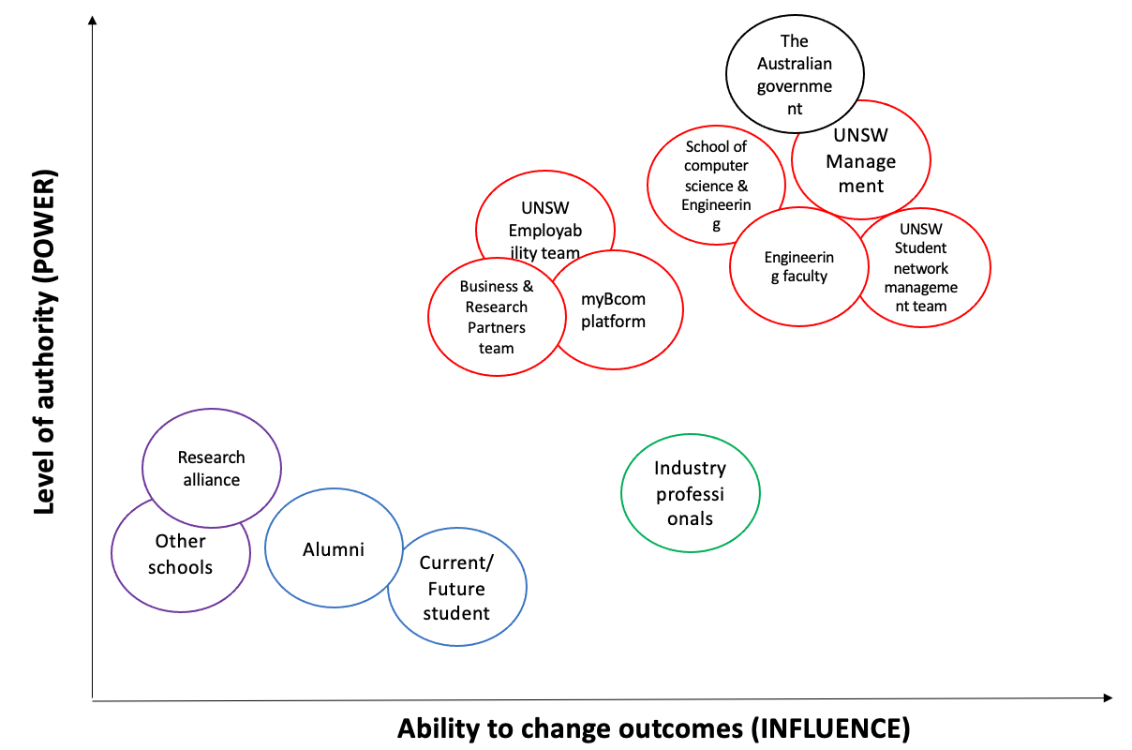

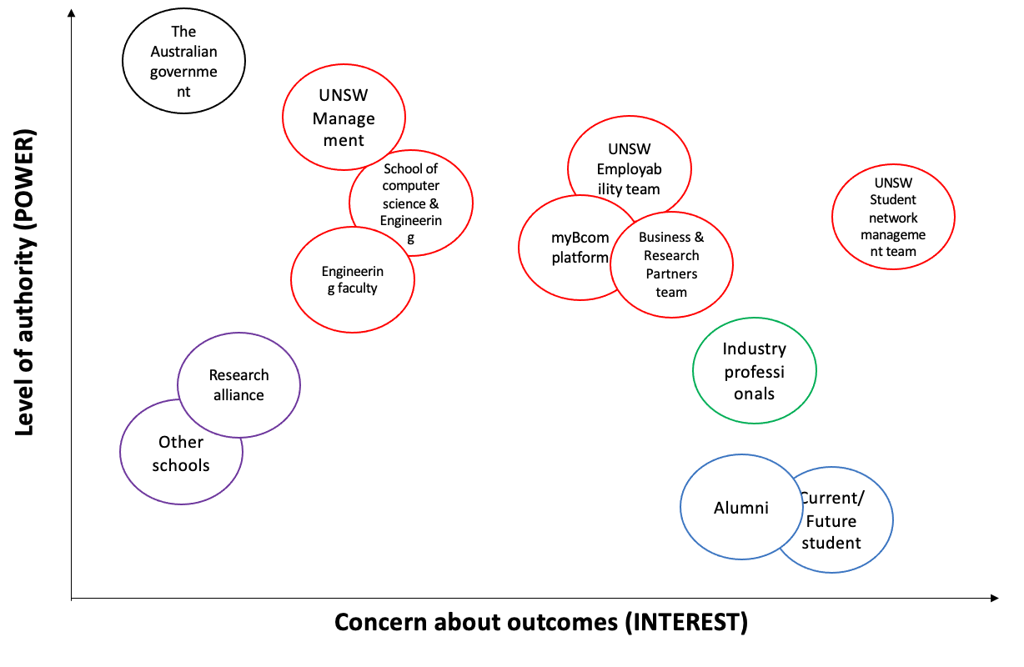

## **3.4 Stakeholder Engagement**

Stakeholders typically fall into five categories: resistant, unaware, neutral, supportive, and leading. An accompanying chart provides a comprehensive list of all potential stakeholders, highlighting both their current and desired levels of engagement. In this chart, 'C' denotes the current position of the stakeholder, while 'D' signifies the desired position. To better understand and assess the level of engagement for each stakeholder, it is useful to use the Stakeholder Engagement Assessment Matrix as outlined in PMBOOK 2017, p.522. to strategize stakeholder involvement effectively.

# 4. Schedule management

## **4.1 Overview of schedule management**

The project schedule is organized and showcased through various representations to ensure a comprehensive understanding of the project timeline and dependencies:

* Gantt Chart - Offers a visual representation of the overall project timeline, indicating the duration and sequence of each task.
* Network Diagram - Illustrates the interrelationships and dependencies between tasks, pinpointing critical paths that require special attention.

The former two will be presented in 4.1 and 4.2, and the larger diagram is placed in appendix(clearer version)

## **4.2 GANTT CHART**

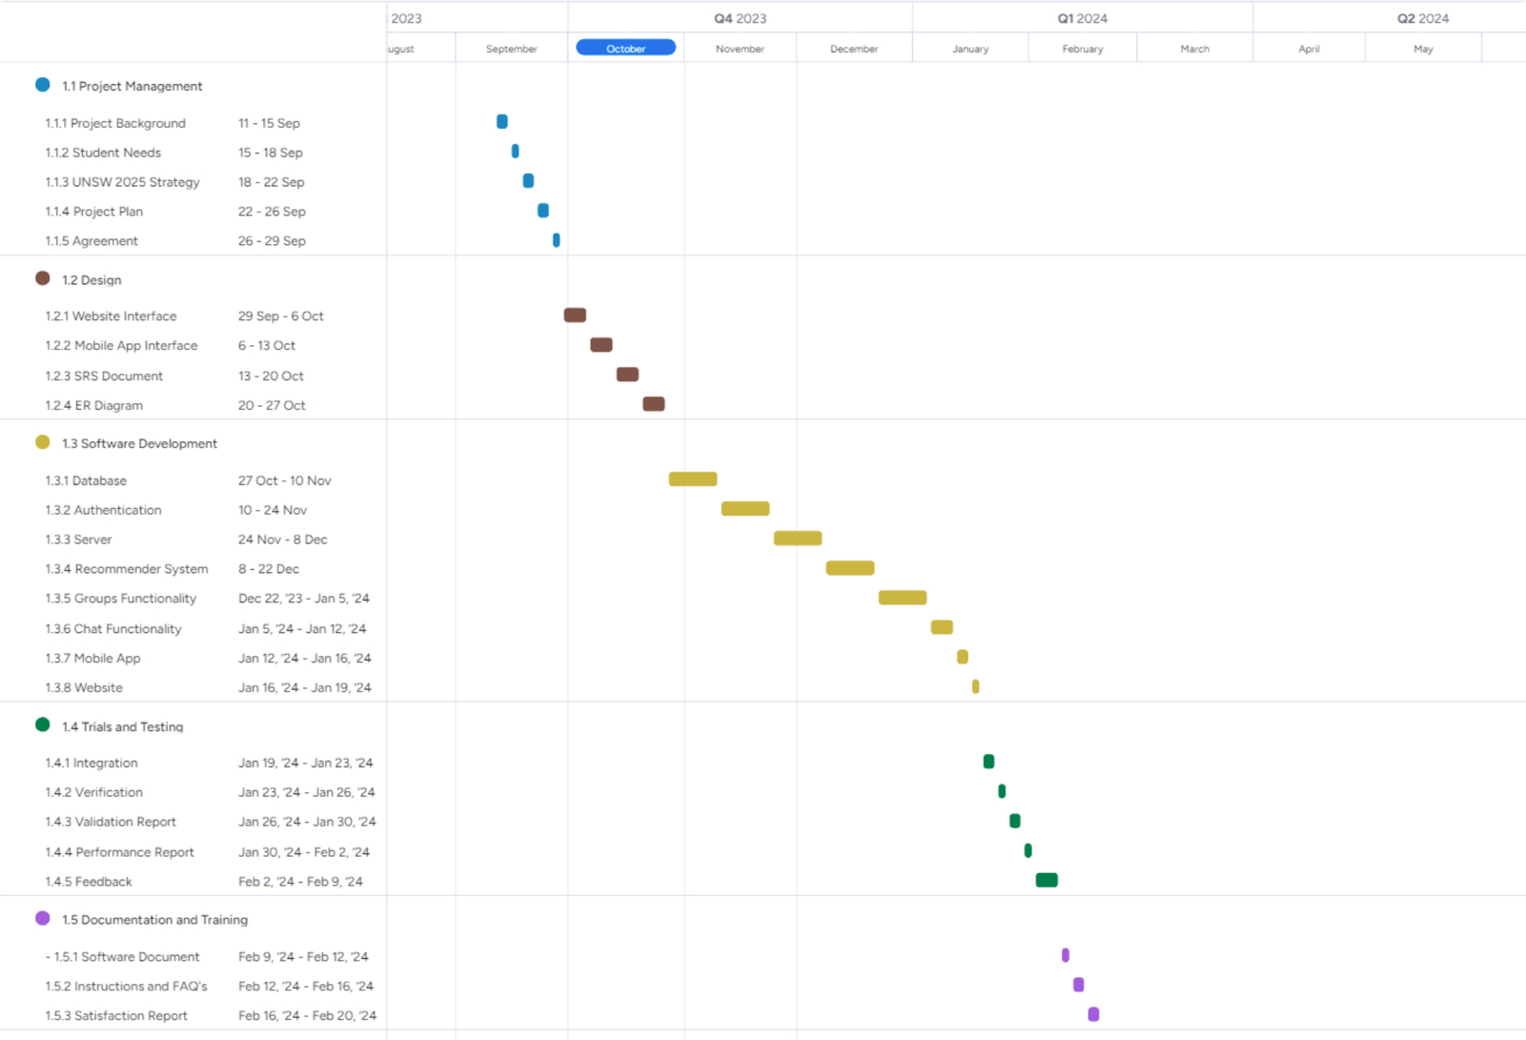

## **4.3 network diagram**

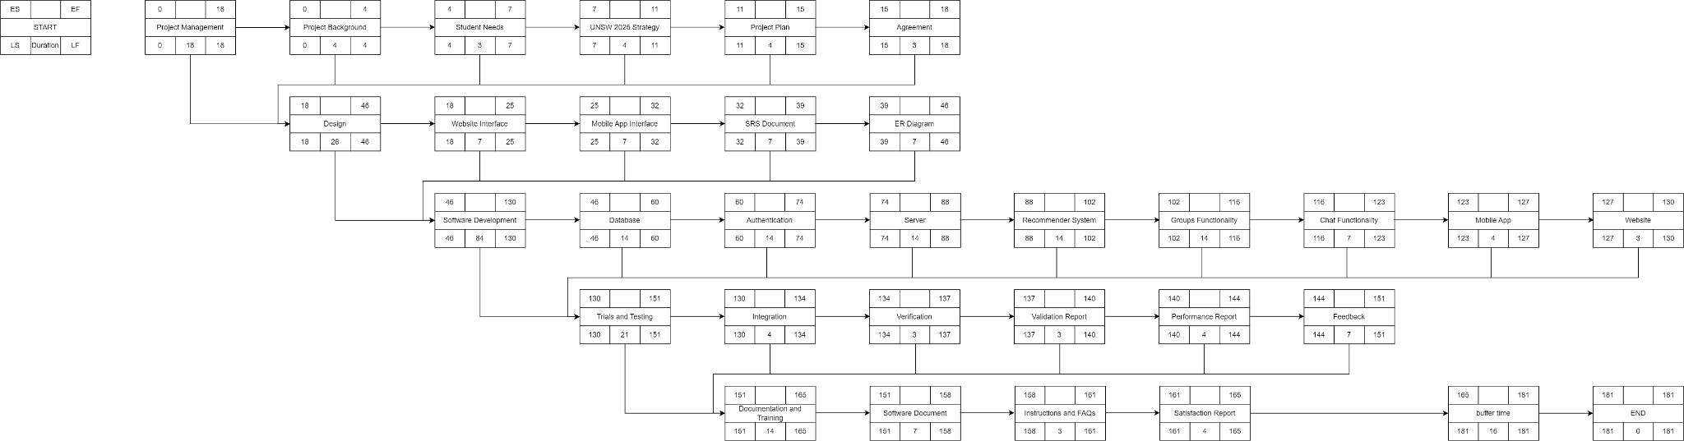

# 5. bUDGET management

## **5.1 Overview of BUDGET management**

The allocated budget for the project is $400,000. A detailed structure of the budget and the time phased budget are given below. As shown in the table below, we use a total of $348,660.64 with a further $51,000 in reserve. Contingency is only taken where there exists an identified risk.

The following salary estimates have been used for calculations.

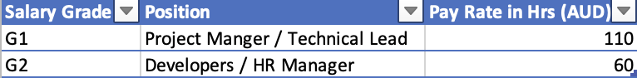[1] Salary data taken from Indeed.com.au average salaries for Sydney.

## **5.2 BUDGET ESTIMATION TABLE**

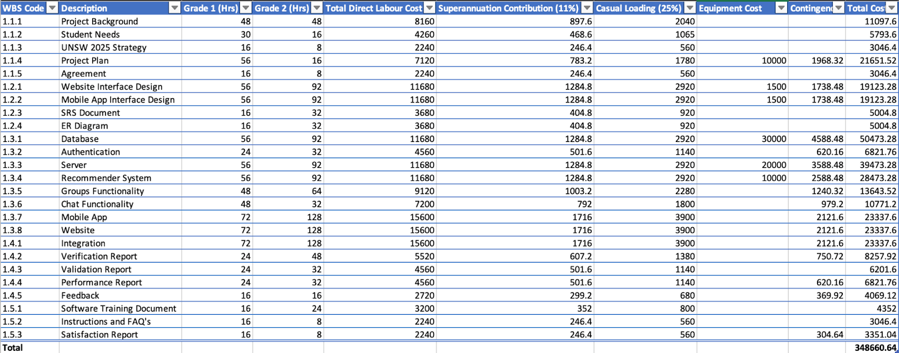

## **5.3 integrated project budget (time phased budget)**

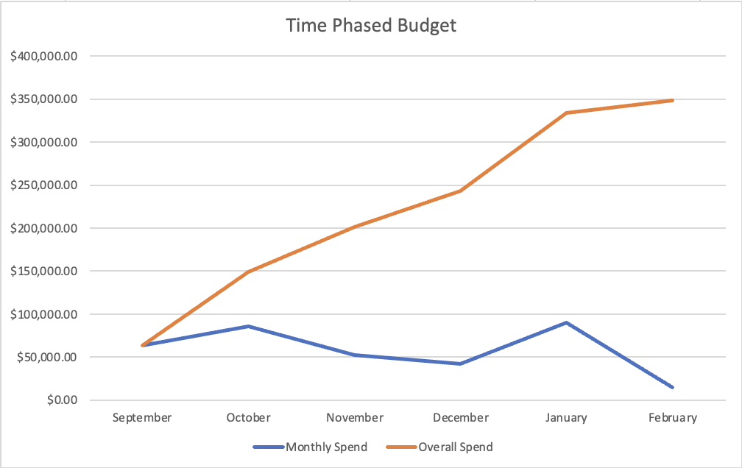

# 6. risk management

## **6.1 Overview of risk management**

To effectively manage risks for the UNSW Student Network Platform project, the project team should begin by identifying potential risks specific to technical, project management, organizational and external risks. There are two levels to demonstrate each risk in likelihood and impact with five levels, Different strategies including mitigate, transfer, avoid and accept should be used to reduce the effect from risks. Once the risks happen, there are corresponding actions to handle the contingencies. Clear communication and documentation are essential to keep stakeholders informed and maintain comprehensive records.

## **6.2 RISK IDENTIFICATION**

## **6.3 Risk assessment**

A comprehensive risk assessment for the UNSW Student Network Platform project involves evaluating the potential risks, their likelihood and impact.

**5.3.1 Likelihood**

1. Very low probability (<0.1%): Only happens in some extreme situations.
2. Low probability (0.1%~1%): It is hard to find related records of other projects.
3. Medium probability (1%~10%): the risk may occur and it can be found in other projects.
4. High probability (10%~30%): the risk is likely to happen and several records can be found in other projects.
5. Very high probability (>30%): the risk is expected to occur in the project.

**6.3.2 Impact**

1. Trivial: there is almost no impact on the project.
2. Minor: need to spend some time or fund to solve.
3. Moderate: need to spend much time or fund to solve.
4. Major: Most parts of the project are affected.
5. Critical: Almost all of the work are affected.

|  |  |  |  |  |  |  |
| --- | --- | --- | --- | --- | --- | --- |
| **0-5 LOW** | | **IMPACT** | | | | |
| **6-10 MODERATE** | |
| **11-15 HIGH** | | **1** | **2** | **3** | **4** | **5** |
| **16-25 EXTREME HIGH** | |
| **LIKELIHOOD** | **1** | 1 | 2 | 3 | 4 | 5 |
| **2** | 2 | 4 | 6 | 8 | 10 |
| **3** | 3 | 6 | 9 | 12 | 15 |
| **4** | 4 | 8 | 12 | 16 | 20 |
| **5** | 5 | 10 | 15 | 20 | 25 |

## **6.4 Risk register (response and contingency plan)**

*PT = Project Team

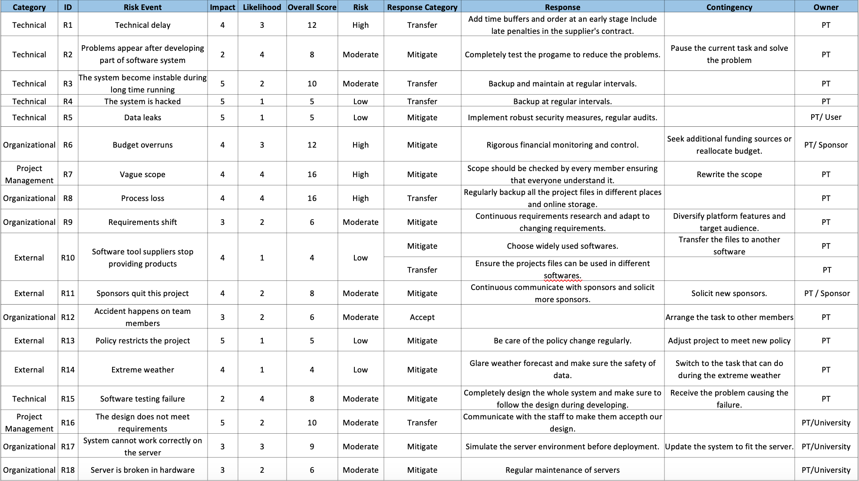

# 7. project communication management

## **7.1 Overview of communication management**

The project manager will be the responsible person for the communication with stakeholders of the project and the project team throughout the whole project period. This can avoid any misunderstanding when discussing important matters. The project manager should ensure the relevant information is delivered to stakeholders and fulfil the project objectives within the time and budget. In order to perform above targets, a series of reporting activities and documents are set up. Section 7.2 provides the Primary Communication Documents and Section 7.3 provides the Communication Plan throughout the project. Both sections will provide the details of each related communication document and our communication plan of the project.

## **7.2 primary communication documents**

|  |  |  |  |  |  |
| --- | --- | --- | --- | --- | --- |
| **Primary Communication Documents** | | | | | |
| **Reporting Document** | **Description** | **When** | **Method** | **From** | **To** |
| Meeting Agenda and Minutes | Meeting Agenda and minutes will include action items, work progress, any changes need to be made for the platform, any comments from different stakeholders and any necessary matter needed to be discussed during the meeting. | Agenda: One Business day before meeting  Minutes: At most 1 week after meeting | Email | Project Manager | Relevant Team(s) |
| Organization Chart | The organization chart provides the job position and contact information of different team members. | At the beginning stage | Email | Project Manager | Outside Stakeholders |
| Action Item Lists | Summary about all action items of the project. | Daily | Email | Project Manager | Relevant Team(s) |
| Progress Report | The report provides information of the platform progress. The information includes Budget details and Working Schedule | Short updates weekly  Detail report once a month | Email | Project Manager | Relevant Team(s) |
| Request for Information | Document to request any information needed during the project period. | Anytime when team members need information | Email | Project Manager or Team Member | Relevant parties |
| Training Manual and Documents | The document involves operating information of the platform. The team members can refer to the document for later development. | Finish during the platform demo development | Email | Project Manager | Relevant Team(s) |
| Testing and Validation report | The report provides the performance of our product, and any bugs need to be fixed before launch | After finish platform demo and before launch | Email | Project Manager | Relevant parties |

## **7.3 project communication plan**

|  |  |  |  |  |  |  |
| --- | --- | --- | --- | --- | --- | --- |
| **Project Communication Plan** | | | | | | |
| **Communication Type** | **Objective** | **Channel** | **Frequency** | **Audience** | **Owner** | **Deliverable** |
| Kick off Meeting | Introduction of PM team and briefly describe the project scope, budget, and schedule. | Face to Face | Once at the beginning | 1. All PM team members  2. Major Stakeholders | Project Manager | 1. Meeting Agenda  2. Meeting Minutes  3. Action Items Lists |
| PM team meeting | Review progress of development, discuss any new opportunities and threats. Consider corresponding measures. | Face to Face/ Online | Weekly | 1. All PM team members | Project Manager | 1. Meeting Agenda  2. Meeting Minutes  3. Action Items Lists  4. Risk Register update |
| UNSW Project team meeting | Discuss the linkage between our platform and UNSW platform and how to cooperate with UNSW to promote and utilize the platform | Face to Face/ Online | Fortnightly before launch | 1. Relevant PM team  2. UNSW Relevant team members | Project Manager | 1. Meeting Agenda  2. Meeting Minutes  3. Action Items Lists |
| Platform Design team Meeting | Review design of the platform and discuss feedback from relevant stakeholders to make necessary changes. | Face to Face/ Online | Weekly or as needed | 1. Front-end Team members  2. Relevant PM team members | Project Manager | 1. Meeting Agenda  2. Meeting Minutes  3. Action Items Lists |
| Infrastructure team Meeting | Review database and server of the platform and discuss feedback from relevant stakeholders to make necessary changes. | Face to Face/ Online | Weekly or as needed | 1. Back-end Team members  2. Relevant PM team members | Project Manager | 1. Meeting Agenda  2. Meeting Minutes  3. Action Items Lists |
| Emergency Meeting | Immediate discussion any sudden changes of the project scope, schedule, or budget | Face to Face/ Online | As needed | 1. Relevant Stakeholders  2. Relevant PM team members | Project Manager | 1. Meeting Agenda  2. Meeting Minutes  3. Action Items Lists  4. Risk Register update |
| Project Review Meeting | Discuss about any afterward adjustments needed for the project | Face to Face/ Online | Once after finish platform test and validation  Afterward: as needed | 1. Relevant PM Team Member(s)  2. Software Construction Team  3. Relevant team member | Project Manager | 1. Meeting Agenda  2. Meeting Minutes  3. Action Items Lists  4. Any necessary changes to budget or schedule |
| Platform Promotion Meeting | Discuss how to deliver advertisement materials to UNSW students and Industry Professionals. | Face to Face / Online | Weekly meeting before promotion launched | 1. Relevant PM Team Member(s)  2. Promotion Team  3. Relevant Stakeholders | Project Manager | 1. Meeting Agenda  2. Meeting Minutes  3. Action Items Lists  4. Advertisement Materials after meeting |
| Website Announcement and updates | Providing new info to our users and other stakeholders about the platform launch, status, and update | Platform Website, Print Media, social media, and Email | As needed | 1. Platform Users  2. Relevant Stakeholders | Project Manager | 1. Platform launch announcement  2. Updated items lists |

# 8. HUMAN RESOURCE management

## **8.1 Overview of HUMAN RESOURCE management**

To ensure the successful development and implementation of the UNSW Student Network Platform, a dedicated 6-person project management team has been carefully crafted, with their roles meticulously aligned with the project's Schedule and Work Breakdown Structure (WBS). This team comprises a blend of external professionals and internal experts. The Project Manager and Technical Lead come from external hires, alongside a Development Engineer and an HR Manager. Additionally, we have harnessed the expertise of internal resources, including a Communication Coordinator, a Change Management Specialist, and a Training and Development Specialist. This diverse team has been thoughtfully assembled to oversee and steer the project towards its successful completion.

## **8.2 PROJECT ORGANIZATION CHART**

The project's organisational structure will be hierarchical, with the Project Manager at the top, followed by the Technical Lead, HR Manager, Communication Coordinator, Change Management Specialist, and Training and Development Specialist. This structure ensures clear lines of authority, responsibility, and communication throughout the project.

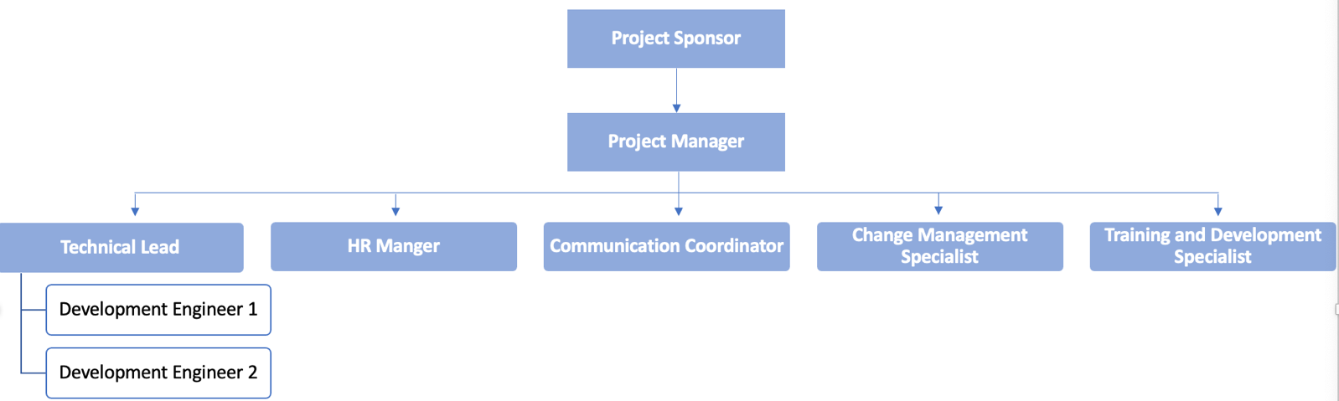

## **8.3 roles and responsibilities**

Duration and salary information can be found in the chart in Section 4.2, and the Communication Coordinator, Change Management Specialist, and Training and Development Specialist are part of the Project team described in Section 3.2.

**8.3.1 Project Manager**

* Position: Full-Time
* Duration: 500 hours
* Salary: $55,000
* Responsibilities:

1. Overall project coordination
2. Ensuring adherence to the project's objectives and timelines
3. Budget and timeline management
4. Stakeholder engagement and communication
5. Risk management and mitigation
6. Reporting to senior management

**8.3.2 Technical Lead**

* Position: Full-Time
* Duration: 450 hours
* Salary: $49,500
* Responsibilities:

1. Managing the technical aspects of platform development
2. Overseeing technological implementation
3. Ensuring technical compliance with project requirements
4. Collaborating with development team
5. Problem-solving on technical challenges
6. Reporting technical progress to the Project Manager

**8.3.3 Development Engineer**

* Position: Full-Time
* Duration: 450 hours
* Salary: $27,000 * 2 persons
* Responsibilities:

1. Collaborating with the Technical Lead and team to design and develop the technical components of the UNSW Student Network Platform.
2. Participating in the agile software development process, contributing to the creation of platform features and functionalities.
3. Writing, testing, and maintaining code to ensure the platform meets technical requirements.
4. Troubleshooting and resolving technical issues or bugs as they arise.
5. Collaborating with the Technical Lead and the rest of the development team to ensure technical alignment with project goals.
6. Staying up-to-date with industry best practices and emerging technologies to support the platform's development.
7. Reporting development progress and technical challenges to the Technical Lead.

**8.3.4 HR Manager**

* Position: Full-Time
* Duration: 400 hours
* Salary: $24,000
* Responsibilities:

1. Human resource management and recruitment
2. Team dynamics and personnel matters
3. Ensuring a conducive work environment
4. Addressing HR-related issues and conflicts
5. Liaising with HR department of UNSW
6. Reporting HR-related updates to the Project Manager

**8.3.5 Communication Coordinator**

* Position: Intramural cooperation
* Duration: 400 hours
* Responsibilities:

1. Internal and external project communications
2. Stakeholder engagement and awareness campaigns
3. Regular project updates and status reports
4. Feedback mechanism establishment
5. Maintaining consistent communication channels
6. Reporting communication-related progress to the Project Manager

**8.3.6 Change Management Specialist**

* Position: Intramural cooperation
* Duration: 400 hours
* Responsibilities:

1. Facilitating the integration of the platform into UNSW's existing systems
2. Addressing resistance and challenges during transition
3. Stakeholder engagement and transition planning
4. Ensuring a smooth adoption of the platform
5. Managing changes within the project
6. Reporting change management progress to the Project Manager

**8.3.7 Training and Development Specialist**

* Position: Intramural cooperation
* Duration: 400 hours
* Responsibilities:

1. Identifying training needs for project team members and users
2. Developing training materials and programs
3. Ensuring team and user proficiency with the platform
4. Providing ongoing training support
5. Reporting training and development progress to the Project Manager

|  |  |  |  |  |  |  |  |
| --- | --- | --- | --- | --- | --- | --- | --- |
| **Deliverable** | **Project Manager** | **Technical Lead** | **Development Engineer** | **HR Manager** | **Communication Coordinator** | **Change Management Specialist** | **Training and Development Specialist** |
| Project documentation | A | C | R | C | C | C | C |
| User profile | R | R | C | R | C | C | C |
| Central Control system | R | A | R | R | I | C | C |
| UNSW career high system | R | R | C | C | C | C | C |
| Study resource pool | R | C | C | C | I | C | C |
| Deployment trial | R | R | C | R | C | A | C |
| Advertisement plan | C | C | C | R | R | C | C |
| Training resources | C | C | C | R | R | C | A |

R – Responsible for completing the work

A – Accountable for ensuring task completion/sign off

C – Consulted before any decisions are made

I – Informed of when an action/decision has been made.

## **8.4 TRAINING AND DEVELOPMENT**

The significance of diversified team training in this project lies in its commitment to equipping all members, especially non-technical team members responsible for communication, change management, and HR aspects, with the essential skills and knowledge required to effectively carry out their roles and responsibilities. This approach acknowledges the diverse expertise and backgrounds of the team members, ensuring that each one is well-prepared for their specific tasks.

The training and development efforts will be customized for each role:

* Communication Coordinator: This role will undergo training to effectively communicate project updates, engage with stakeholders, and raise awareness about the project. They will gain communication skills and strategies to keep the team informed.
* Change Management Specialist: Training will centre on facilitating the integration of the new platform into UNSW's existing ecosystem, addressing resistance, and efficiently managing transitions. The specialist will receive guidance on change management best practices.
* Training and Development Specialist: This role will be responsible for developing training materials for end-users. Training and Development Specialists will be trained to create user-friendly materials and programs, ensuring that users can effectively navigate and utilise the UNSW Student Network Platform.

By tailoring training to these distinct roles, the project ensures that every team member, regardless of their background, contributes effectively to the project's success.

## **8.5 CHANGE MANAGEMENT**

Change management is a critical aspect of this project, particularly regarding the integration of the UNSW Student Network Platform into the university's existing systems. The Change Management Specialist will play a key role in developing strategies to mitigate risks, manage budget implications, and ensure adherence to the project schedule. This specialist will also focus on the impact of these changes on human resources and the organisation as a whole.

The Change Management Specialist will work closely with the project team to identify and assess potential risks associated with the implementation. By understanding these risks, they can develop strategies to ease the transition and minimise disruptions that could impact the project's budget and schedule.

Additionally, the specialist will collaborate with the HR Manager to evaluate the impact of changes on the project team and provide support to manage any challenges or resistance that may arise. They will ensure that human resources adapt smoothly to the new platform and maintain productivity.

Change management efforts will be aligned with budget constraints and project schedules, allowing for effective management of resources and potential budget adjustments. The specialist will monitor the project's schedule and budget closely to address any deviations resulting from the change management process.

# reference

UNSW(2020). 2025 Strategy Update, Sydney: UNSW Sydney.

Project Management Institute. (2017). PMBOK. Newtown Square: Project Management Institute

UNSW Employability: https://www.unsw.edu.au/employability

UNSW Business & Partners: https://www.unsw.edu.au/about-us/collaboration/business-research-partners

UNSW myBcom: https://www.handbook.unsw.edu.au/undergraduate/courses/2023/COMM0999 / https://www.youtube.com/watch?v=q9RvrGUwwVQ

# aPPENDIX

## **gANTT CHART (EXCEL VERSION)**

